DOTA2 Recent Game Analyzer

Team DOTA Scrubs

Screenshots:

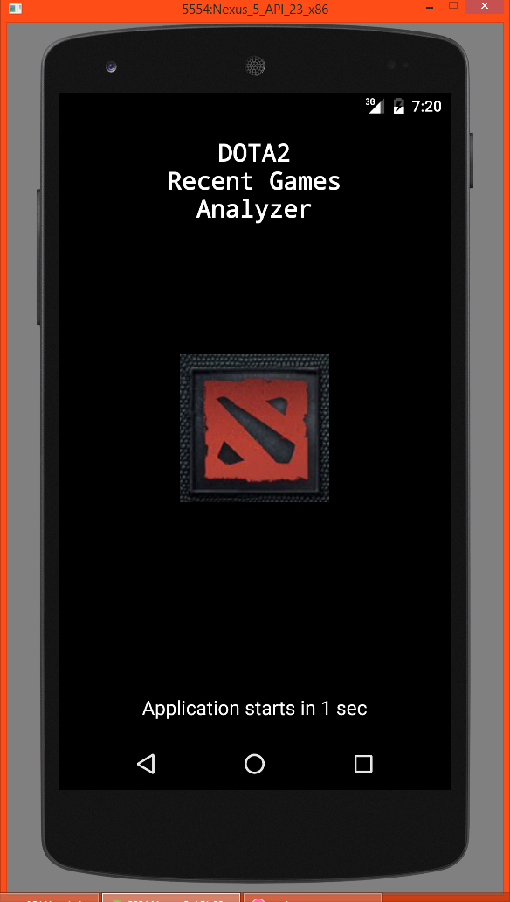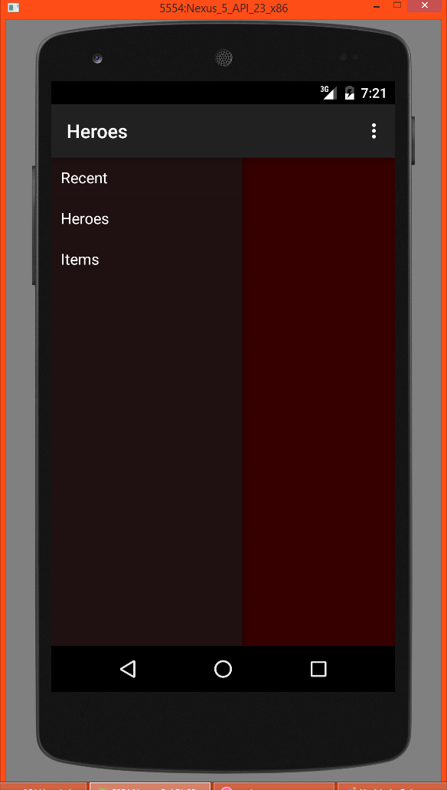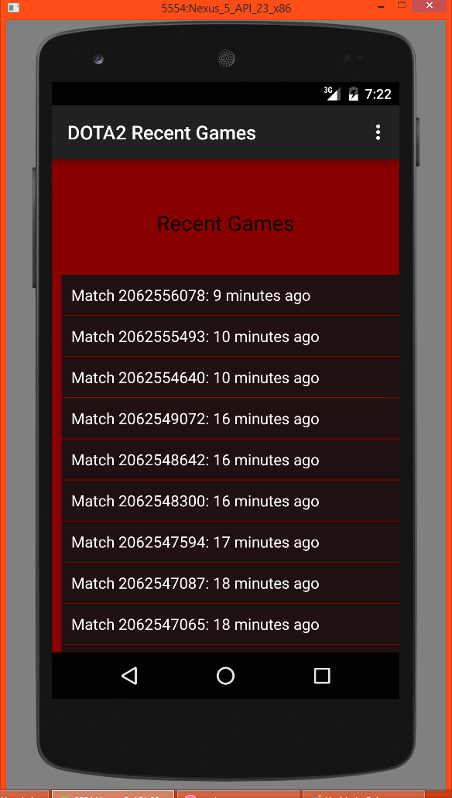

Description:

Quickly search and analyze recent DOTA2 games and brush up on your game knowledge! With our app checking out the meta game has never been easier. Results for recent games along with how each player did are available at your fingertips. You don’t need to tab out of your game to check a hero’s abilities, you don’t even need to type! Just scroll through the list and find what you need! Not completely sure how a hero or item interacts or is used? There’s an extra section for looking up your preferred hero and favorite items.

Features:

* Browse recently played DOTA2 games.
* Use even while in game. There’s no need to tab out anymore!
* Select individual games for more specific information.
* Scroll through a list of heroes and learn about them.
* Scroll through a list of items and decide on your next purchase while in game.

The Defense Of The Ancients 2 (DOTA2) name and all related graphics belong to Valve. To play the game, go to: <http://store.steampowered.com/app/570/>

We are not associated or affiliated with Valve in any way.